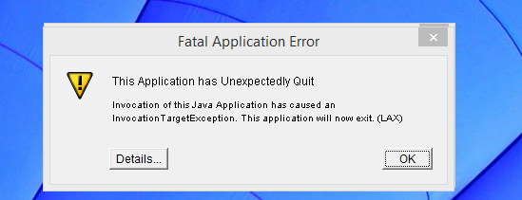

Carreguei nos details e aparece:

ZeroGu2: Windows DLL failed to load
at ZeroGa2.b(DashoA10*..)
at ZeroGa2.b(DashoA10*..)
at com.zerog.ia.installer.LifeCycleManager.b(DashoA10*..)
at com.zerog.ia.installer.LifeCycleManager.a(DashoA10*..)
at com.zerog.ia.installer.Main.main(DashoA10*..)
at sun.reflect.NativeMethodAccessorImpl.invoke0(Native Method)
at sun.reflect.NativeMethodAccessorImpl.invoke(Unknown Source)
at sun.reflect.DelegatingMethodAccessorImpl.invoke(Unknown Source)
at java.lang.reflect.Method.invoke(Unknown Source)
at com.zerog.lax.LAX.launch(DashoA10*..)
at com.zerog.lax.LAX.main(DashoA10*..)

